

User Manual
for
CustomerConnectTM Enterprise

Issued on : 06 March 2006
Version 1.0
Index

1 Overview 4
2 References 4
3 Purpose 4
4 System Features 4
5 Server Administration 5
5.1 Access Control 6
5.1.1 User Management 6
5.1.2 User Creation and Update 7
5.1.3 User Role Management 8
5.1.4 Role Creation and Update 9
5.2 Service Administration 10
5.3 Configuration Settings 12
5.3.1 SMPP Panel 13
5.3.2 Services Panel 16
5.3.3 General Panel 18
6 Bulk Messaging 20
6.1 Customer Group Management 21
6.2 Customer Information Management 24
6.3 Bulk Message Sending 26
7 Message Reporting 27
7.1 Reporting Overview 27
7.1.1 Message Log 27
7.1.2 Transaction Summary Report 28
7.1.3 Campaign Log 29
7.1.4 Throughput Log 31
7.1.5 Process Log 32
7.2 Report Features 32
7.2.1 Export Options 33
7.2.2 PDF View 33
7.2.3 Excel View 33
7.2.4 Print View 34
8 Template Management 35
8.1 Template Creation/Update/Delete 36
9 Campaign Management 38
9.1 Campaign List 38
9.2 Campaign Creation 39
9.3 Campaign Update 39
9.4 Campaign Message Sending 40
10 File Based Messaging 42
10.1 Bulk Messaging 42
10.2 Personalized Messaging 42
10.3 Messaging constraints 43
11 Pull Messaging 43
11.1 Normal Pull Message 43
11.2 Campaign Messages 44
11.3 Delivery Response 44
12 Bulk E-Mail 44
12.1 File Based Mailing 44
12.2 Web based mailing 45
13 Status Monitor 46
13.1 Message Details Section 47
13.2 Message Throughput Section 47
13.3 Services Section 48
13.4 SMS Service Section 48
13.5 Message Log Section 48
14 Log File specification 48
14.1 Application Specific Logs 49
14.2 Access Logs 49
15 Mail Alerts 49
16 User Guide, FAQ and Product information and Change Details 50
17 Frequently Asked Questions 51

Overview

CustomerConnect Enterprise edition deployed at Samba Financial Group, serves as an SMS based messaging interface to Samba’s customers for delivering various alerts and notification. The system also provides pull facility for customers to receive information from bank by sending an SMS. The system has been customized specifically for Bank Samba to fetch SMS messages through STAR database which is the repository for outgoing SMS messages coming from different applications.
The system also provides web-based interface to enable Samba to send SMS based alerts for predefined customer groups. This interface can be used by business personnel to send alert messages to bank customers as and when required. There is a separate interface for creating new campaigns, which can be used to send campaign messages to customer. Response for these campaigns from different customers are captured into a campaign report for analysis purposes.

References

Sl. No | Document Name | Location
1 | Installation Guide (Installation Guide.doc) | Samba repository
2. | Functional Specification Document (Samba_FSD.doc) | Samba repository
3. | Technical Specification Document (Samba_TSD.doc) | Samba Repository

Purpose

The purpose of this user manual is to give details of using CustomerConnect Enterprise edition customized for Samba to the users of the system. This document captures the implemented features, various aspects of the system usage, configuration settings and troubleshooting for the common problems. This document also describes the integration details with the Samba’s application services.

System Features

As described in the installation manual, CustomerConnect Enterprise contains two main components:

- CustomerConnect Enterprise Server
- CustomerConnect Administration console

CustomerConnect server provides basic connectivity to the SMPP server at STC and reader interfaces for applications to send SMS messages. The server is installed as an NT service on windows server following the installation procedure and once started runs continuously. In case, the server machine goes down in unforeseen circumstances, the server starts automatically on machine restart.

The administration console of the application is complementary to the CustomerConnect Server, which provides various Configuration Settings, Service Administration, Access Control Management, Group SMS Sending, Customer/Group Management, Template Creation, Status Monitoring, Campaign Management and Reports.

Server Administration

A web-based Administration Console has been provided to control functions in CustomerConnect enterprise server. Administration Console can be accessed only by authenticated users. More on these roles and the services controlled by them has been discussed in Access Control section.

Currently, CustomerConnect Enterprise server has been deployed at three distinct server machines. Here is the list of IP Addresses and URLs to access administration consoles of the three servers :

Server | IP Address | Admin Console URL
SMS Server 1 | 10.8.33.55 | http://10.8.33.55/ccadmin
SMS Server 2 | 10.8.33.101 | http://10.8.33.101/ccadmin
SMS Server 3 | 10.8.33.84 | http://10.8.33.84/ccadmin

This will bring the interface for login:

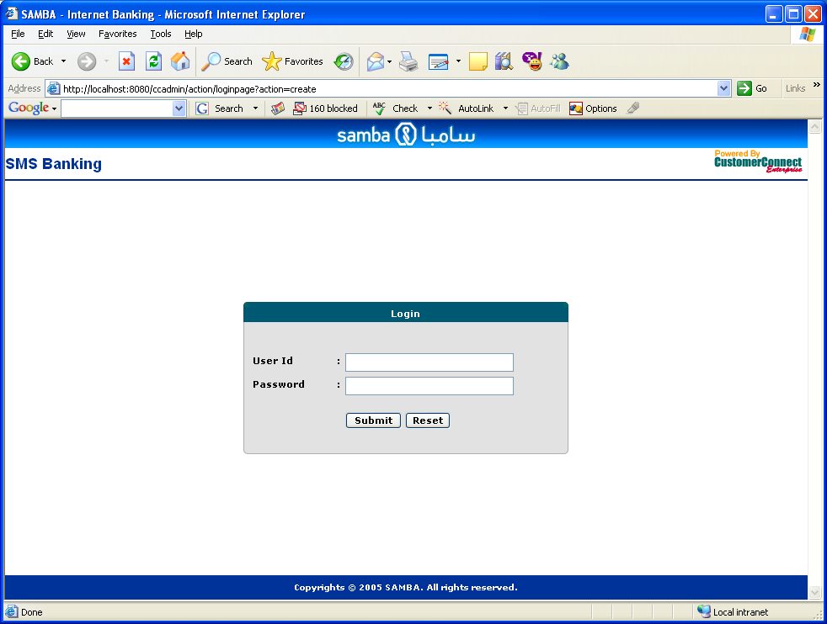

Access Control

There are four predefined access levels for users as:

- Super Administrator
- Administrator
- Business User
- User Creator

Super Administrator - has access to all the facility available for administration and controlling the server. There is a pre-defined user in CustomerConnect having Super Administrator role. User Id and Password for the Super Administrator role has been pre-configured. Additional users can not be created with this role.

Administrator - Users with administrator role can only monitor whether the system is working properly or not. Based on the information in the monitor, they would take appropriate action.

Business Users - can view MIS reports available in the system, send bulk messages, create customer groups and see some of the administration reports like throughput log and process log.

User Creators - Users with this role will be able to create new users in the system. There is an interface to create new user, update existing users and delete users from the system. This interface is accessible only to users with User Creator roles. The user management screen is described below.

User Management
User management screen will be available by clicking on the Users link from the left navigation menu. The first screen displays list of all the users available in the system. From this interface, users can be created updated and deleted.

To delete, system users need to select checkbox for each users and click on delete button in the User List screen.

For adding new users, system users should click the add button and for modifying an existing user one can click the link available on user name.

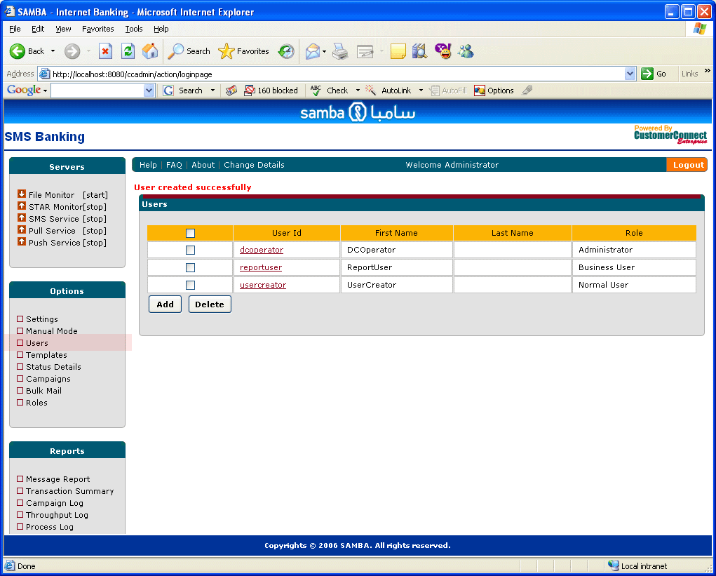

User Creation and Update
For user creation User Id and password are required to be more than 6 characters in length. Following two screens describe the create and update interface for users.
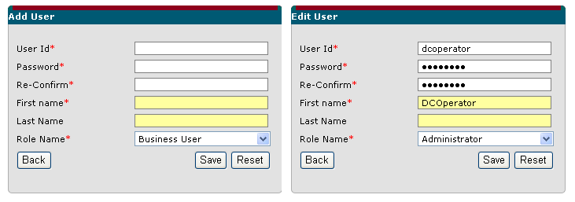

User Role Management
CustomerConnect also provides interface to define new roles other than pre-defined role i.e SuperAdmin. The User Role management screen is available only to Super Administrators by clicking on the Roles link from the left navigation menu. In the Role Management Screen all roles available in the system are displayed. Further addition, deletion and update can be performed from this screen itself.

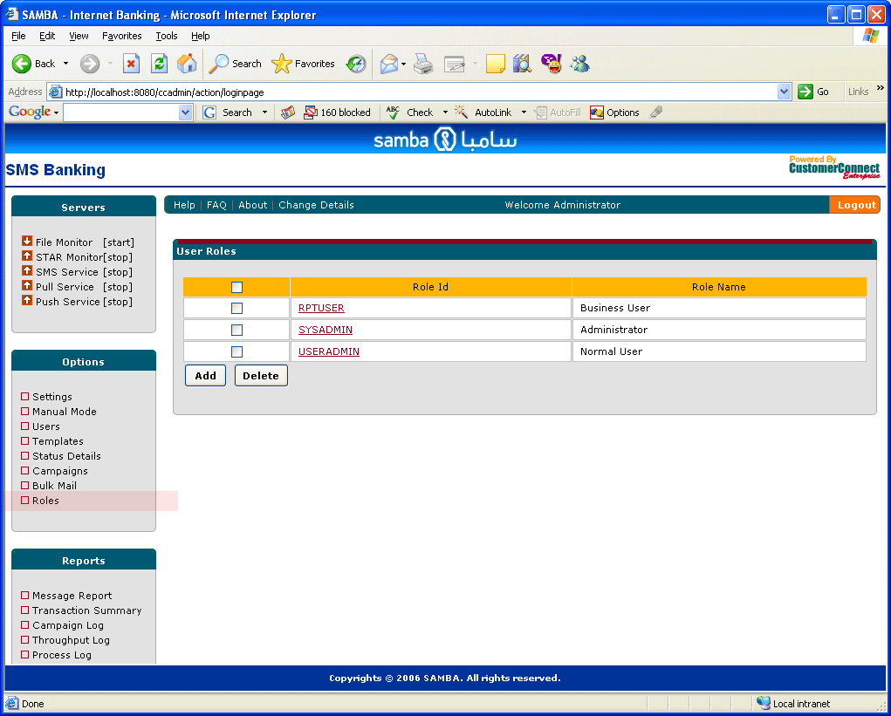

Role Creation and Update
Role creation can take place by clicking on the add button from the role management screen. Users need to specify the role Id and role name. A list of Business Objects configured in the system is also available, on which permission can be specified for this new role by selecting the checkbox.

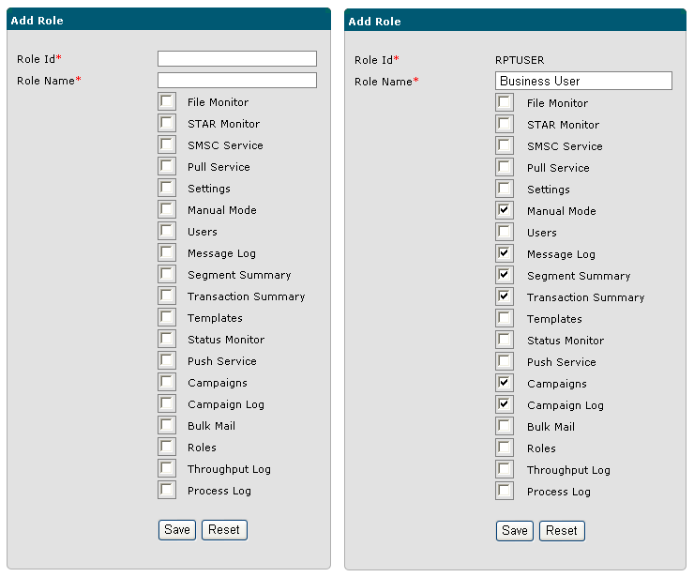

Service Administration

CustomerConnect provides various services which can be controlled through admin interface. Such services are :
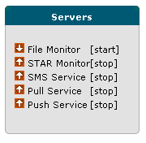

File Monitor service monitors a specified source directory for message files. The source directory is specified using the configuration settings of the management console. As soon as a new message file arrives, file monitor picks it up and sends SMS as per the details available in the file. This service is utilized by Manual Mode (Group) messaging as well. Stopping this service will stop message sending for customer groups and bulk messaging through file upload.

STAR Monitor service monitors Samba’s STAR database to receive messages from different applications. The frequency and number of records to be read from the database is configured through services settings panel. Other database access parameters like URL, username, password and table from where messages are picked is also specified through database settings parameter in services settings. Please refer to Settings section for specific details.

SMS Service is the basic service to send SMS messages, if this service is stopped, all sessions are unbound from the SMSC and no messages will be sent to the end users. File Monitor and STAR monitor services will stop picking up new information. Messages currently loaded in the server will be stored temporarily in the send message queue and will be sent as soon as this service is started.

Pull Service takes care of processing PULL messages originated from Customer’s mobile. If this service is stopped Pull messages are not received by the application for processing and they remain at the gateway. Once the service is started all pending messages are processed unless they have already been received by other receivers if configured on other servers.

Push Service takes care of sending the messages from Internal Queue to the gateway. Stopping this service will stop sending messages out side and messages will be kept in the queue. This service should not be stopped in normal scenarios, But only while trouble shooting for small intervals.

In the screen shown above, [Start/Stop] links can be utilized to start and stop mentioned services, if a service is stopped, the start link will be available and if service is running, the stop link will be available for users. The arrow on the left indicates the current status of the service. Up arrow signifies running state and down arrow indicates stopped/suspended state of the service. When ever any stop command is issued a mail will be sent to system administrator, regarding the operation performed.

All these services are independent from each other and can be started and stopped in any sequence by users.

Configuration Settings

The configuration settings are provided through the Options main menu option. Clicking on Settings menu option from the main menu opens up the settings interface in the content frame

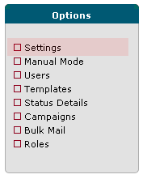

The configuration settings (shown below) panel consists of three tabbed pane. Each tabbed pane provide configuration for different services built into CustomerConnect system. Following section gives tabular description of each of these settings and their expected value. The figure below displays SMPP setting available on server 1.

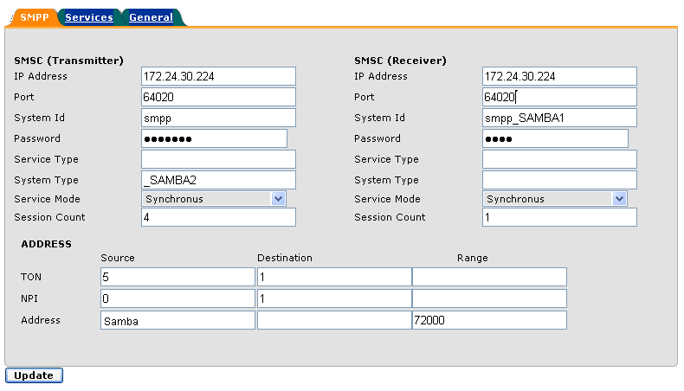

SMPP Panel
Provides settings for SMPP connectivity. There are three sections in the screen corresponding to Transmitter (Push) Session, Receiver (Pull) Session and Address parameters.

- Transmitter related settings – Required for outgoing SMS

Field Name | Description | Value
IP address | This is the IP address of the SMPP server deployed at STC | As provided by STC, in the current configuration environment, IP Address being used is : 172.24.30.224
Port | Port number at which SMPP server is running from STC | As provided by STC, in the current configuration environment, port used is : 64020
System Id | Username using which the SMPP service will be connected | smpp(As provided by STC)
Password | Password for the username provided above | Not Disclosed (As provided by STC)
Service Type | Indicates type of service being used for communication | Defaulted to CMT (Cellular Mobile Technology). This parameter is not mandatory.
System Type | System type parameter is provided by the SMPP provider as per their applications This is required for billing purposes | _SAMBA2 (Provided by STC)
Service Mode | The connection mode in which the communication will take place | Defaulted to Synchronous. The synchronous mode waits for response to come up as soon as a message sending request is made to the server. Depending on the server response time other requests will have to wait for that time period. Synchronous mode of communication is more reliable therefore, it is recommended to use Synchronous mode for better Quality Of Service. However, throughput in asynchronous mode is quite high.
Session Count | No of transmitter sessions available to send messages. The limit on number of session is specified by the Service Provider. Currently, the total number of sessions including transmitter and receiver is configured to 12 by STC for Samba | Server 1 – 4  Server 2 – 2  Server 3 – 2

- Receiver related settings – Required for incoming SMS

Field Name | Description | Value
IP address | This is the IP address of the SMPP server deployed at STC | As provided by STC, in the current configuration environment, IP Address being used is : 172.24.30.224
Port | Port number at which SMPP server is running from STC | As provided by STC, in the current configuration environment, port used is : 64020
System Id | Username using which the SMPP service will be connected | ssmpp_SAMBA1(As provided by STC)
Password | Password for the username provided above | Not Disclosed (As provided by STC)
Service Type | Indicates type of service being used for communication | Defaulted to CMT (Cellular Mobile Technology). This parameter is not mandatory.
System Type | System type parameter is provided by the SMPP provider as per their applications This is required for billing purposes | No value (Provided by STC)
Service Mode | The connection mode in which the communication will take place | Defaulted to Synchronous. The synchronous mode waits for response to come up as soon as a message sending request is made to the server. Depending on the server response time other requests will have to wait for that time period. Synchronous mode of communication is more reliable therefore, it is recommended to use Synchronous mode for better Quality Of Service. However, throughput in asynchronous mode is quite high.
Session Count | No of receiver sessions available to receive messages. | Server 1 – 1  Server 2 – 0  Server 3 – 0

- Address Related settings

Field Name | Description | Value
Source TON | TON indicates Type of Number. Source TON specifies Number type for the source address | 5, indicates that the address contains alphanumeric characters.  Other possible values are :  0 – unknown  1 – International  2 – National  3 – Network Specific  4- Subscriber Number  6 – Abbreviated  All other values are reserved
Source NPI |  | 0, This is the setting for Alphanumeric TON  Other possible values are :  1 – ISDN  3 – Data  4 – Telex  6 – Land Mobile  8 – National  9- Private  12 – Internet  All other values are reserved
Source Address | The address through which all the messages will be sent. This will be displayed as part of the sender’s address | Samba (Maximum 11 English characters are supported by the SMPP API)
Destination TON | TON indicates Type of Number. Destination TON specifies Number type for the destination address | 1, indicates numeric format, For other values refer to Source TON
Destination NPI | NPI (Number planning Indicator) specifies number type, whether it is local or international number. | 1, indicates international numbers  for other values refer to Source NPI
Destination Address | Indicates the destination address for the message. Currently, this field is being ignored as destination address is dynamically picked up from the message files or notes based messages | Ignored, since it is specified different for each customer
Range TON | TON indicates Type of Number. Range TON specifies Number type for the address range which this application will serve, required for pull messages | Same as TON described above
Range NPI | NPI (Number planning Indicator) specifies number type, whether it is local or international number. | Same as described above
Range address | The address range which this application will serve, if started in the receiver mode. This is the number to which all pull messages will be sent by Customers | 72000 (As provided by STC)

Services Panel

Provides settings for application services like File Monitor and STAR Monitor:

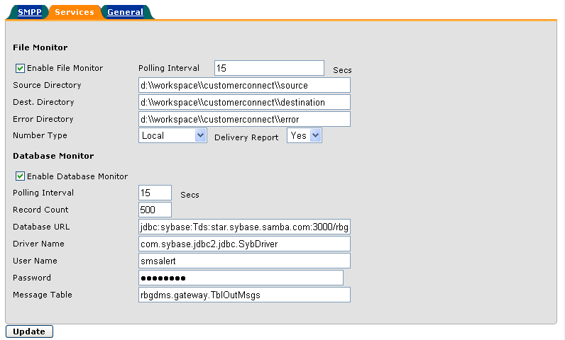

1. File Monitor Related settings

Field Name | Description | Value
Enable File Monitor | Checkbox which indicates that, file monitoring services should be enabled or not. Un-checking this box will not start file monitoring services at system startup | checked
Polling interval | The time interval at which source location will be polled by the application for files | Defaulted to 15 secs
Source Directory | The directory location at which the message file will be kept for processing. | Any valid file location on the current machine. The system can also pick up files from any place on the network identified by the windows environment. However it is not recommended for enterprise level file processing, as network connection failure can disrupt the message processing
Destination Directory | The directory location at which files will be transferred after processing. | Any valid directory on the system. This should not be same as Source directory or the Error directory
Error Directory | The directory location at which files will be transferred if there is any error in processing. | Any valid directory on the system. This should not be same as Source directory or the destination directory. Please check the file format specification section for details on errors in file format.
Number Type | This parameter indicates the format of numbers in a bulk SMS file. Local numbers are specified as 501234567 without a leading zero . International numbers are specified as 966501234567. This setting is global setting and changing this would affect Bulk messages as well as Group messages | Defaulted to Local. Other possible value is International
Delivery Report | This setting specifies , if delivery report is needed for Bulk or group Messages | Defaulted to No.

2. STAR (Database) Monitor Related settings

Field Name | Description | Value
Enable Database Monitor | Checkbox which indicates that, STAR monitoring services should be enabled or not. Un-checking this box will not start STAR monitoring services at system startup | checked
Polling interval | The time interval at which database will be polled by the application for files | Defaulted to 15 secs
Record Count | Number of records to be fetched from database | 500
Database URL | Complete JDBC Url of the database | jdbc:sybase:Tds:star.sybase.samba.com:3000/rbgds
Driver Name | JDBC driver class required to connect to the database | com.sybase.jdbc2.jdbc.SybDriver
Username | Database user name
Password | Database Password
Message Table | Table where the message information is being stored

General Panel
This panel provides general settings related to application

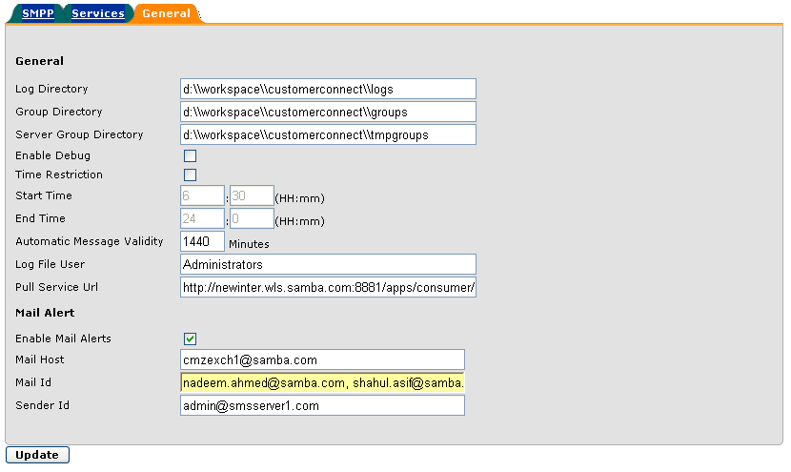

Field Name | Description | Value
Log Directory | Directory location where log files will be stored | Any valid file location on system
Group Directory | Directory location where customer groups created by automatic script is stored. From this location customers are loaded in the group using Update Customer functionality | Any valid file location on system
Server Group Directory | Directory location where temporary files are stored, for internal use | Any valid file location on system
Enable debug | This checkbox is checked when system is required to be checked for critical errors. If this is enabled, this will have some performance implications, shall not be used in production environment | Unchecked
Time Restriction | This checkbox indicates if time restriction for messages is required or not. If this is checked the messages will be sent only with in the specified start time and end time. This is applicable only for Bulk messages and Group Messages | Unchecked
Start Time | Indicates hour and minute at which message sending starts | 06:30
End Time | Indicates hour and minutes when message sending ends | 23:59
Automatic Message Validity | This indicates how long a bulk message will be valid for after that it will be discarded from sending | 1 day
Log File User | This setting is required for security reasons. The log file will be available to only those users who belong to the NT group specified by this parameter. The name should be same as NT group name | Administrators
Pull Service URL | The URL which will be requested for sending PULL messages

2. Mail Alerts related setting

Enable Mail Error Alert | Checkbox which indicates, whether email based alert needs to be sent or not for all the errors | Checked
Mail host | IP address of SMTP server | Cmzexchn1.samba.com
E-mail id | Mail id to which the mail will be sent. This can contain comma separated multiple email ids | nadeem.ahmed@samba.com
Sender | Mail id which will be displayed as from address in the SMTP alert messages | admin@smsserver1.com

Update of mail related setting will take effect only when application is restarted, therefore it is not advised to change these settings frequently.

After specifying all the settings, click on the save button to persist the changes. All the changes take effect once the respective services are stopped and restarted. For example, if SMPP settings related parameters are changed, SMSC Service needs to be stopped and restarted. If File Monitor related settings like Source file location, Destination file location is changed, File Monitor needs to be stopped and restarted.

Bulk Messaging

Administration console also provides capability to send SMS in manual mode. This is required by Business Users to send bulk messages to a group of customers created in the CustomerConnect system. The system expects the groups to be created beforehand using one of the several mechanisms provided by CustomerConnect system. Following sections describe various aspects of bulk messaging.

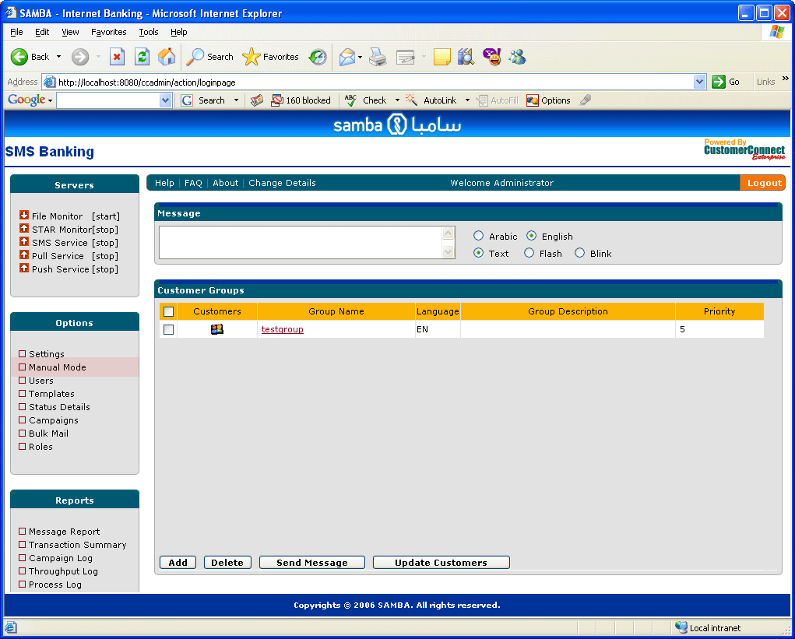

Customer Group Management

Customer Connect provides facility to create customer groups, which can be used to send bulk messages.

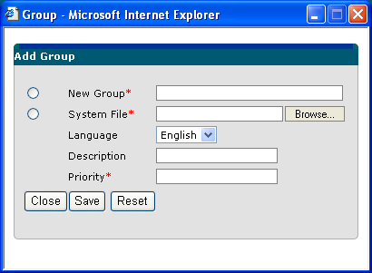

There are two ways in which a group or distribution list can be created. By selecting one of the radio buttons displayed in the above screen, one can create either a new group or a group using system File.

- New group – When user selects New Group radio button, this method is invoked. This method creates a new blank group which does not contain any customer information. Customer information can be manually entered using Customer Management Interface. Refer Fig. 6.2

- Group by System File – When user selects System File radio button, this method is invoked. This method automatically creates a user group by retrieving customer information from a file available on user’s machine. The file should contain Customer information in a specified format. The format looks like as follows :

English:

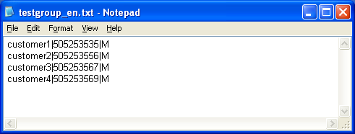

Arabic:
خالد عبدالله المنيع |504190649|M
أحمد محمد حليحل|503448475|M
سامي سامي العسيري |503439537|M

Following points need to be taken care while defining a group:

- Group name should not contain any white spaces.

- All group files generated by application whether English or Arabic should be stored in Unicode format with an extension of “txt”. For example – mobinfor_ar.txt. The language extension like ar and en will be used to identify whether the group is Arabic or English.

- Avoid long names for Groups, The maximum limit for the group name is 50. But It’s better to provide description for the groups about the information they contain and use names just enough to identify them. For example – To identify all credit customers added in the last month. Give a file name like creditlm_en.txt and add the description as “Credit Customers added in Last Month”

Group names can’t be duplicated and system will generate appropriate warning, while adding such a group which already exists in the system. While adding customer information using file appropriate warning will be displayed if file data is incorrect. Even if there is an error in one line of the file, the complete file will not be uploaded and error message will display the error with line number.

Language of the group is relevant only for the new group. For groups being created from system file, the language is specified by the file name itself.

Users can define the priority for a group. A high priority group will be sent messages before the low priority groups.

Groups can be modified by clicking the link on the group from Customer Group List. Group name can also be modified provided no such group exists for the selected group language.

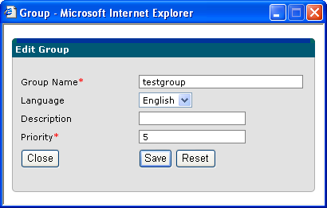

Users can also delete groups by selecting the check box next to the group and clicking on the delete button. Once user confirms the delete operation, selected group(s) is removed from the database along with customer information.

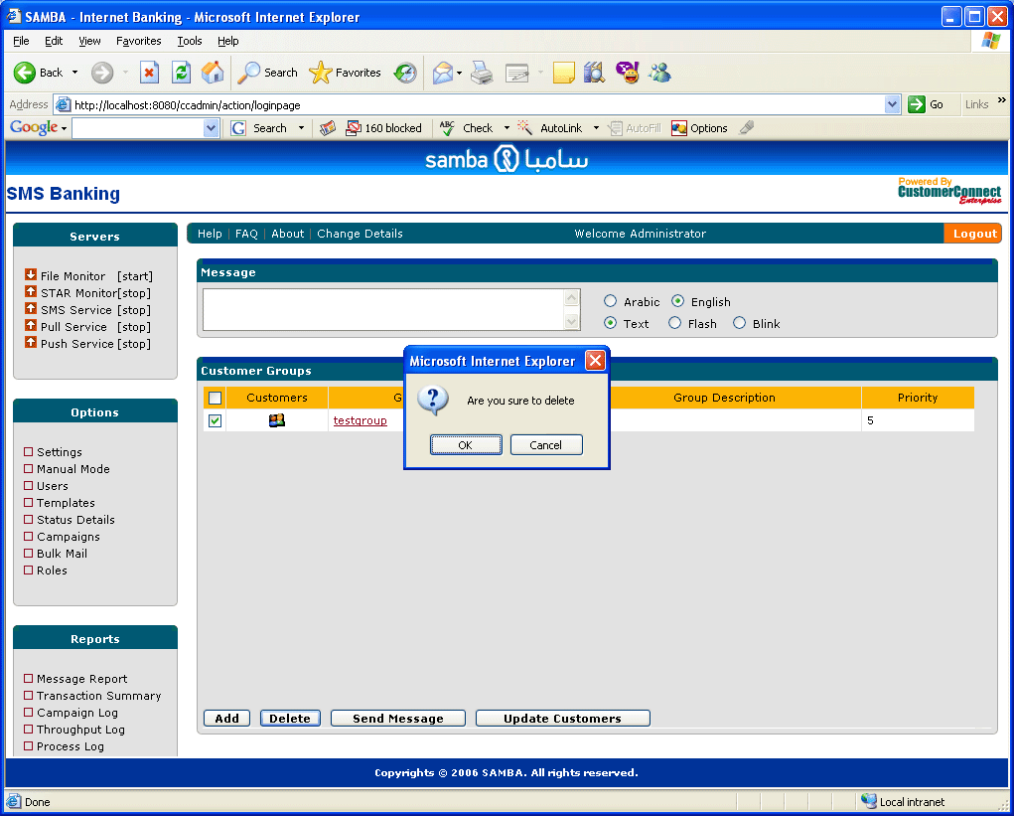

Customer Information Management

Once a Customer group is loaded in customer connect the information available inside the group can be altered using Customer Management interface. This interface can be invoked by clicking the icon available within each group record. A single screen has been provided to insert new customers, update details and deleting existing customers as shown below.

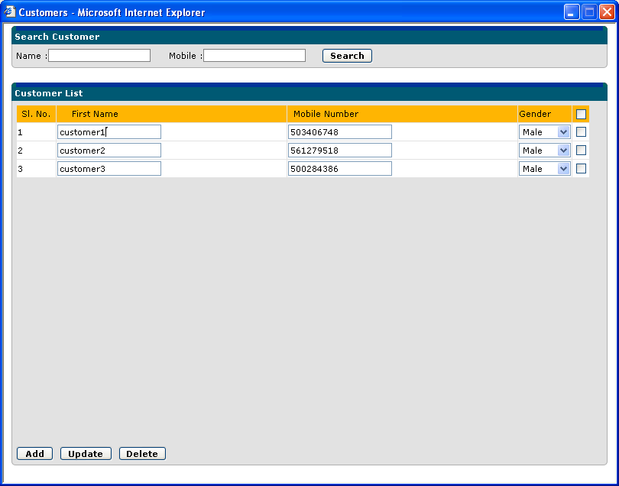

A new Customer can be added by clicking on Add customer button.

To delete one or more customers at a time, check the boxes for each of the customers and click on delete button.

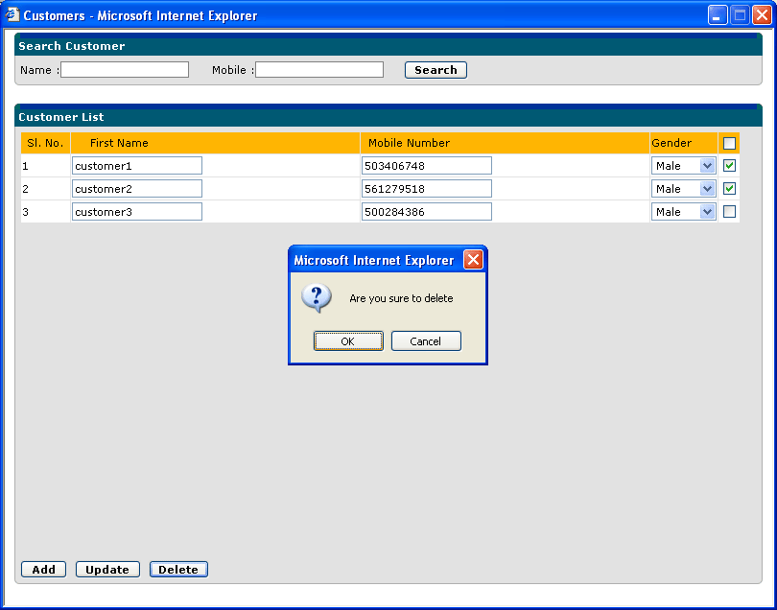

After modifying customer details check the boxes for which the information needs to be updated and click on update button to save the information

Customers can be searched within a group based on their mobile numbers and name.

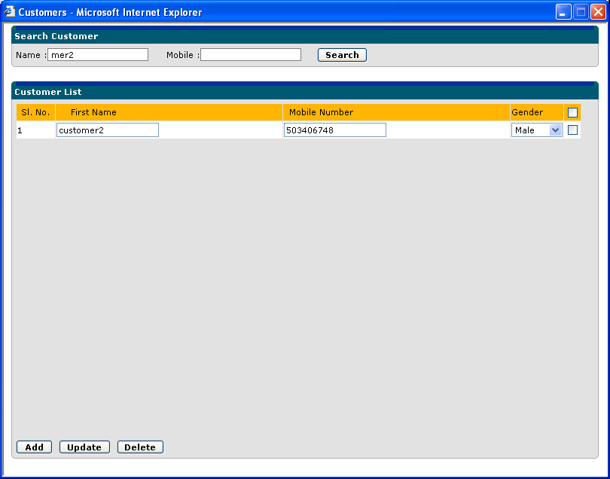

Bulk Message Sending

Once customer groups are created with the above mentioned methods, users can send bulk messages using bulk message interface. The process is as follows:

- Select all the groups to which message is required to be sent. These groups should belong to the same language.
- Select message language as English or Arabic based on the language of selection group
- Select type of message as Text, Flash or Blink
  - Text – These are normal SMS messages
  - Flash – Messages will be sent in flash mode and will appear directly on mobile terminal
  - Blink – Messages will be sent in blink mode and will appear to be blinking on supported mobiles
- Specify the text message in the text field. For personalization, add ${name} parameter wherever you wish to display the first name of the customer. Messages can be specified in English as well as Arabic, based on language selection.
- Click on send message button at the bottom.
- In order to avoid multiple times sending the restriction has been put to send only one group message in a day. The system displays appropriate warnings if any of the restrictions are violated.

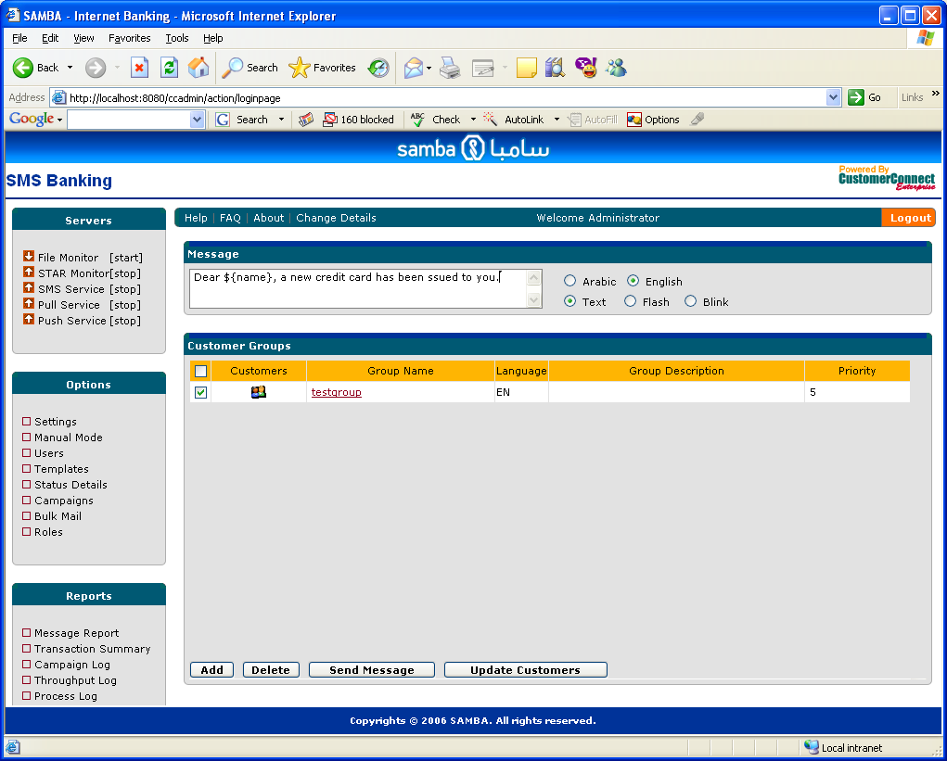

Message Reporting

Reporting Overview

All the messages (Either accepted, Rejected, Received by SMSC) are stored in a log file, which is rolled over on a daily basis. The reporting mechanism on the management console provides management information view to the data. Reports can be viewed using message log menu item in the Reports Menu item. Reports are available for Business Users only. There are three different reports available for the message data.

Message Report

This view displays all the sent messages by the system ordered by date and message source. A summary of total messages sent is displayed for each of the dates available in the range specified.

Message Report should not be viewed for complete day or large duration, as this is only for the purpose of investigating certain messages with in an interval. Because of the limitation in message queue size, it will not be able to format as many as 200000 messages for a day.

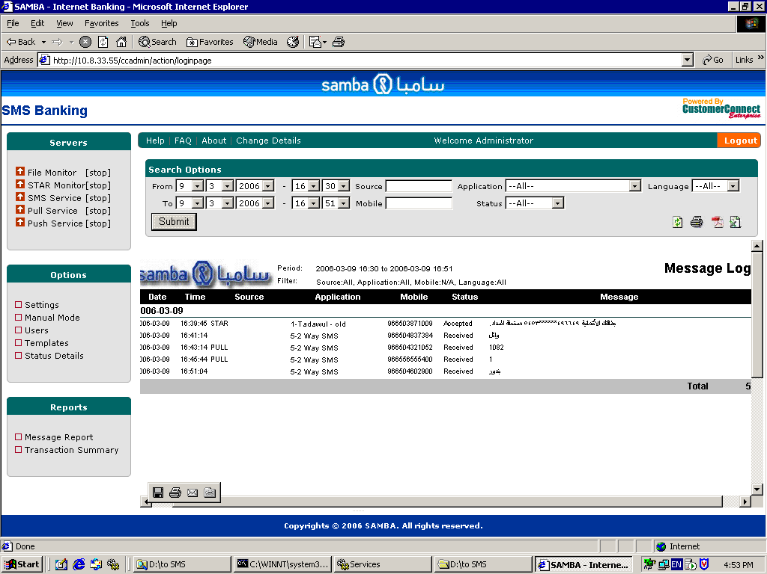

Transaction Summary Report

This is a summary report which displays, summary of all the transactions and total number of messages sent from each of these transactions between a date range
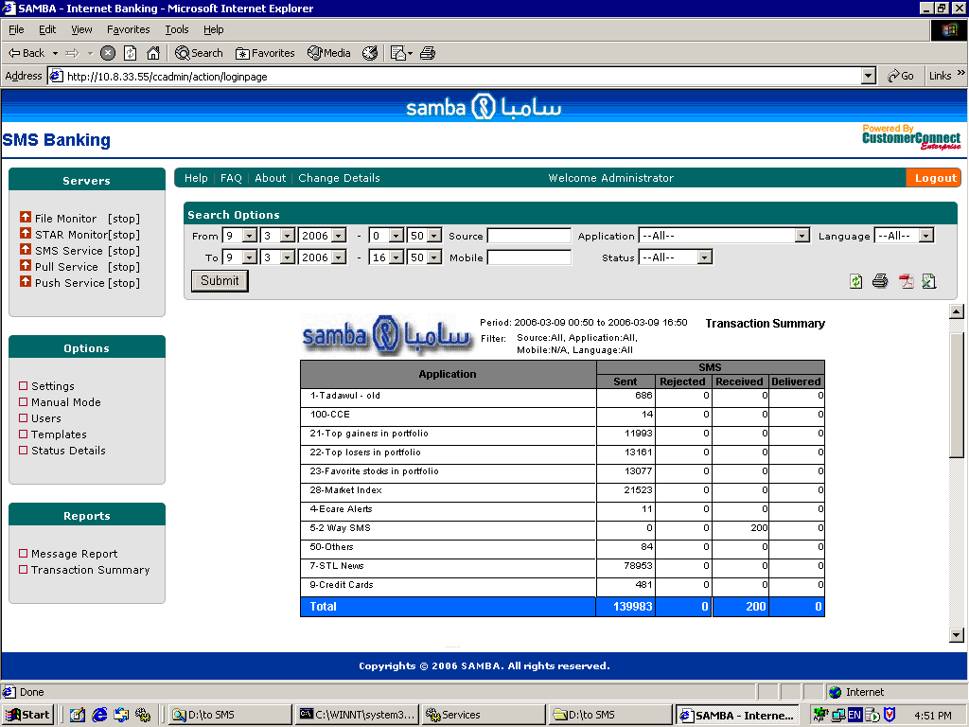

Campaign Log

This is a report for all the campaign responses received by the application

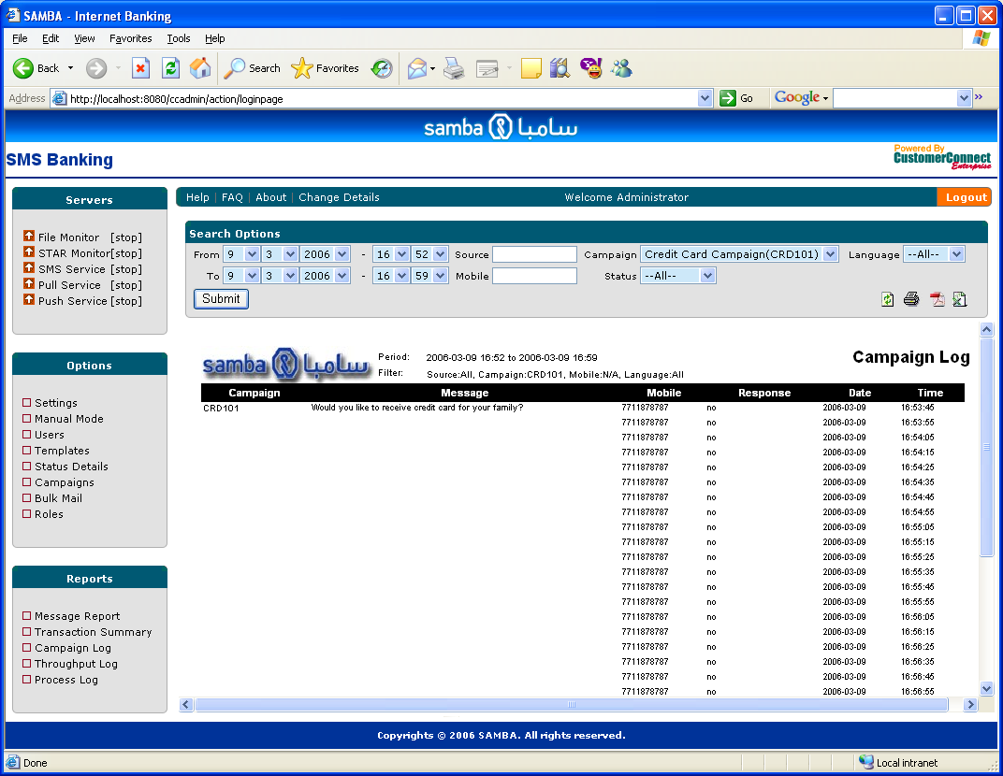

The data display can be filtered on the basis of following parameters:

Filter | Description
- From date & time | Start date and time of the report
- To date & time | End date and time of the report
- Source | Originating source of the message :  STAR – database messages  <File Name> - bulk messages  <Group Name> - group Messages  PULL – Pull message
- Application | Transaction or Application for which message was sent. For complete List of applications refer to Appendix A. (Not available for Campaign Report)
- Campaign | This filter shows list of all the campaigns configured in the system. It is shown only in campaign Log report.
- Mobile number | Mobile number where message was sent
- Language | Message Language
- Status | Sent – Delivered to SMSC successfully  Rejected – Rejected by SMSC  Received – Pull messages  Delivered – Message is delivered to the Customer

By default, From Date and To Date filters show today’s date and time and Application displays “All”. Other filters are either list boxes or free form text fields, where user can specify a complete word or word segment to do complete or partial search respectively (e.g. In the source field if user specifies text like “mob”, report will be generated for bulk file mobinfo.

There are two more reports for monitoring purposes:

Throughput Log

This report displays message throughput details like maximum throughput, minimum throughput and average through put for the system on daily basis

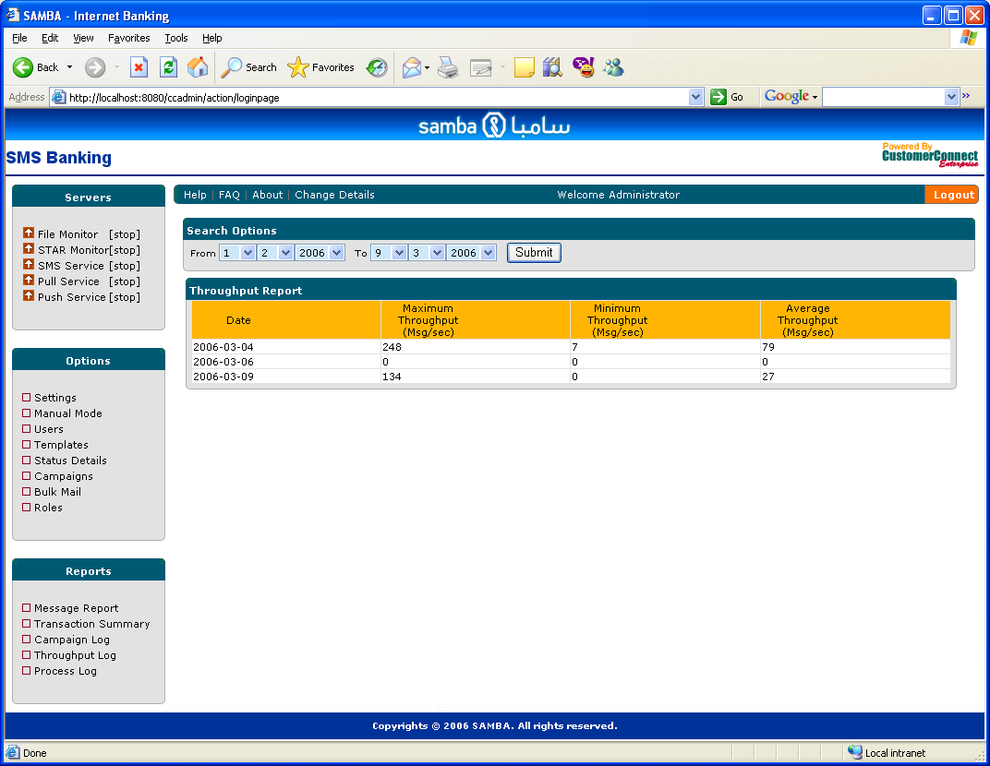

Process Log
This report displays bulk message processing interruptions by high priority messages coming from STAR or other sources.

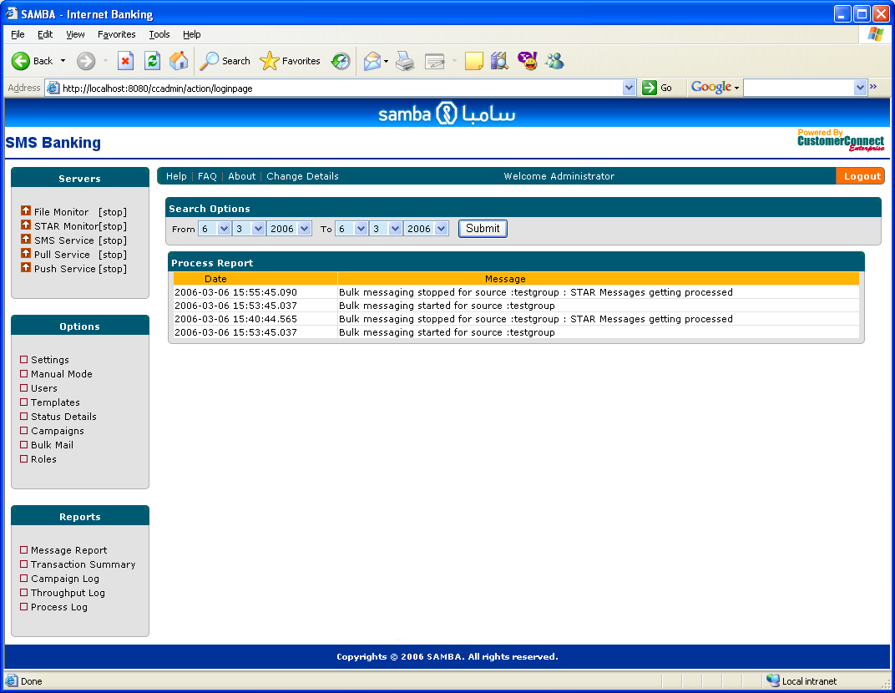

Filter criteria for these two reports includes From Date and To Date only.

Report Features

- Predefined Report Header section, which displays Type of the report and Filter criteria selected.
- Predefined footer section, which displays page count, user information and report generation date
- Capability to export the report in various formats like html, PDF, CSV and excel
- Paged view of report data, page wise navigation capabilities
- Report printing through browser and Acrobat viewer.

Export Options

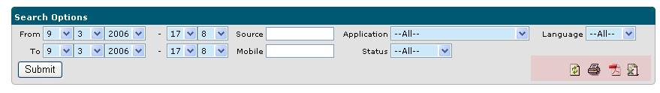

PDF View

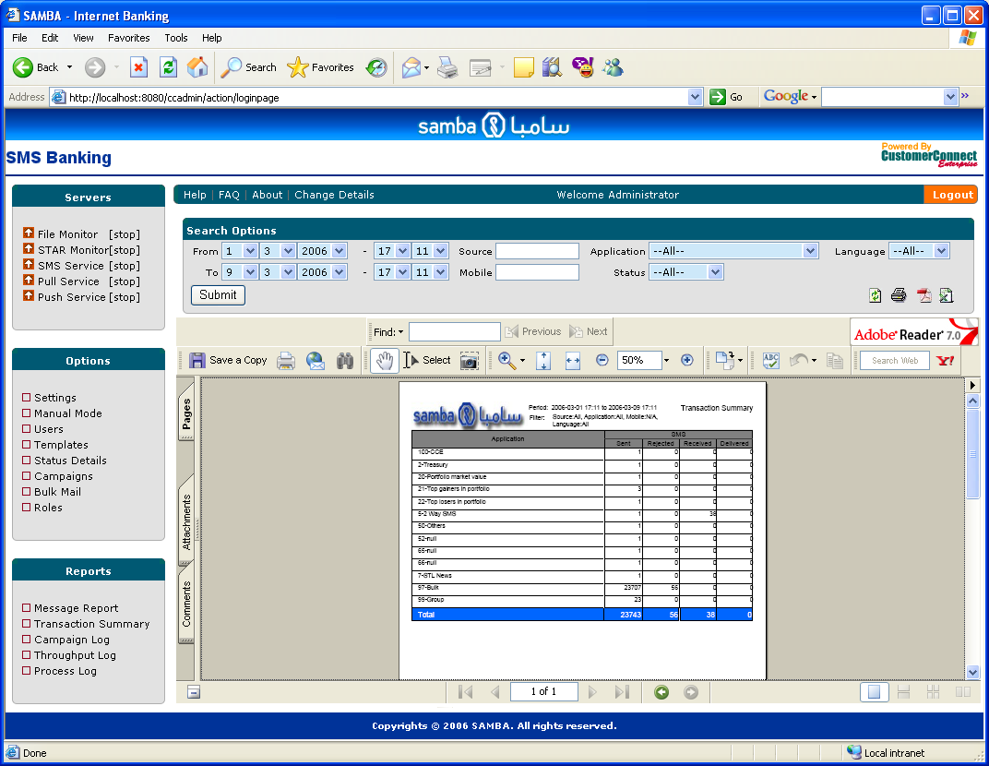

Excel View

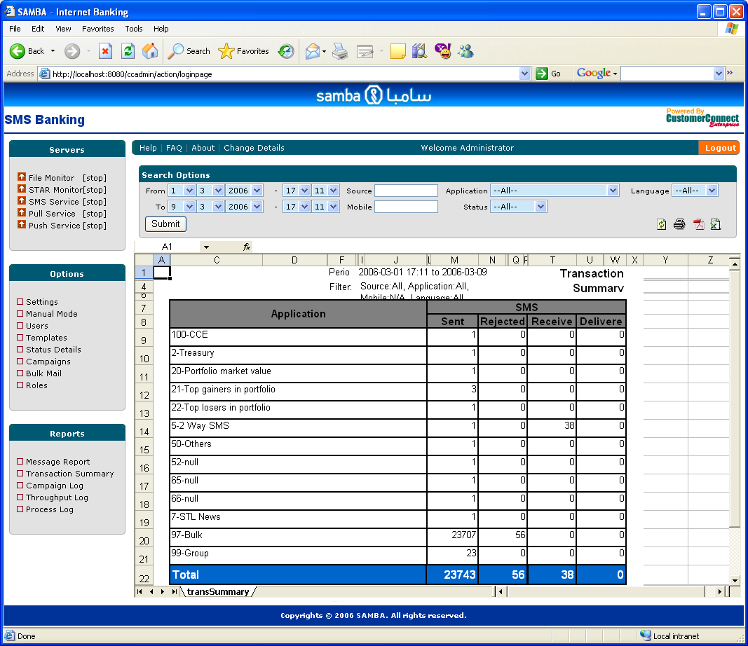

Print View

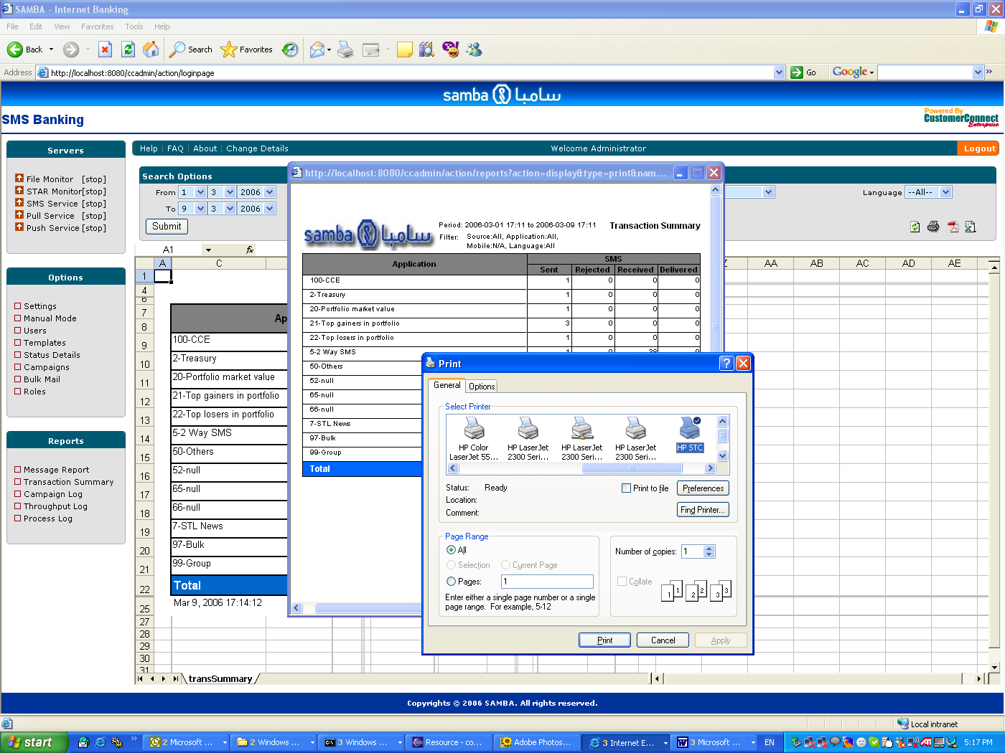

Template Management

CustomerConnect provides interface to manage configurable static data items using message templates. Features include, Creation of new template in multiple languages, Updating of template text, name and language, Deletion of templates and View of template list. There are three types of templates namely:
APPLICATION – Application descriptions and their Ids are stored using this template type
ERROR – All error messages in the system are captured using this template type.
SYSTEM – Other system messages are captured using this template type.

The template management screen can be accessed using template menu option from the left navigation pane:

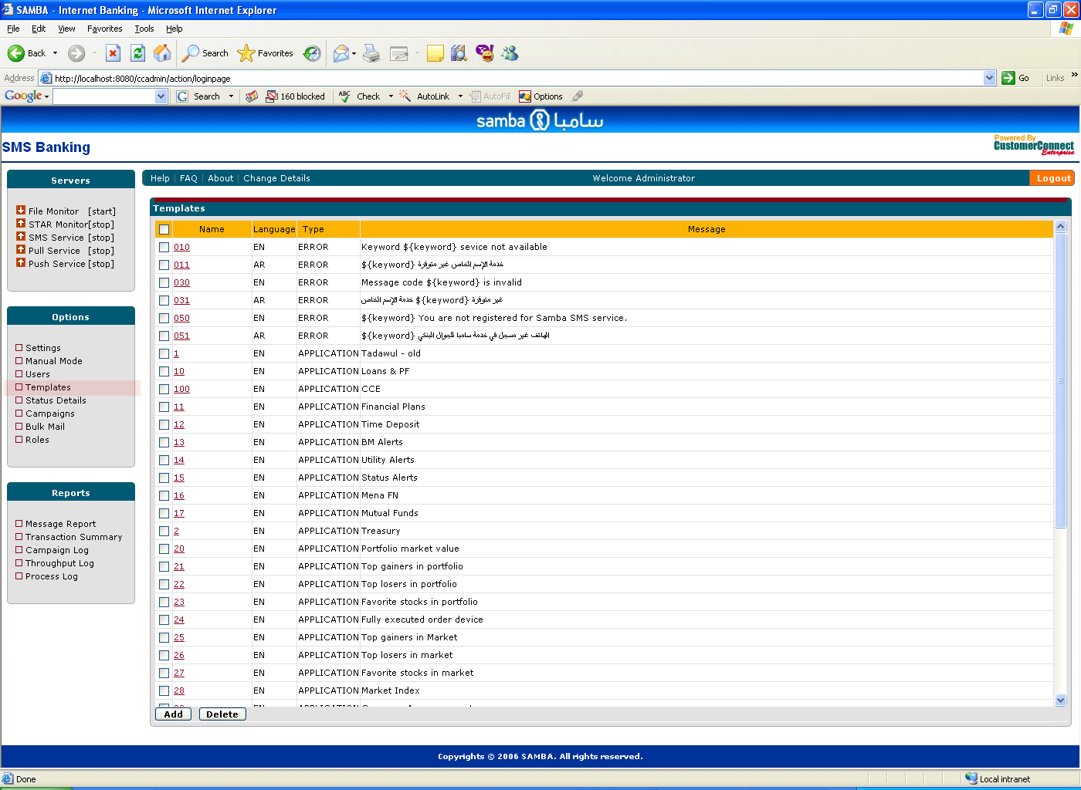

Template Creation/Update/Delete

A template is an ASCII text or Unicode text depending on the language with parameter definitions in between. All the parameters are put within ${ } container. At run time these parameters are replaced with actual values specified in the messages. To create a template, specify name and select appropriate language. Put message text in desired language and specify parameter in between the text, where you want the value to be displayed for this parameter.
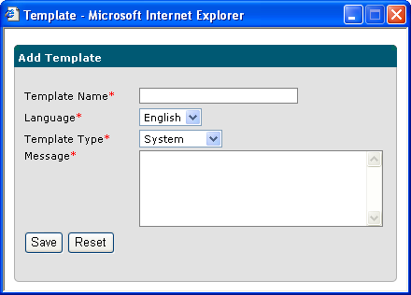

Save the template and make sure that it is displayed in the template list properly.

To update a template, click on the link on the template name, which will open the edit interface for template.

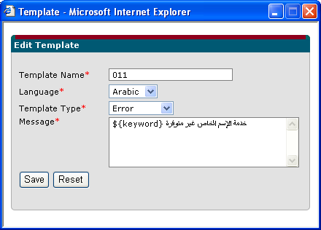

To delete a template, select the list of templates using checkbox and click the delete button.

Following list displays, pre-defined parameters being used in message templates :
- keyword – Required for pull responses generated by CustomerConnect application in case the Servlet results in an error response. The keyword parameter is replaced by the pull message keyword requested by the user.
- code – Required by campaign messages. The code parameter is replaced by campaign code.
- name – This parameter is used while sending group messages if ${name} is used in the group message screen, this parameter is replaced by the name of the customer.

Campaign Management

CustomerConnect provides capability for business users to send promotional messages to customers. The campaign Management screen provides capability to add a new campaign, update an existing campaign, delete campaigns and send campaigns to a group of customers.

A response from Customers for these promotional messages are received and stored for reporting using Campaign Log report.

Campaign Management functionality is also available to Business Users only.
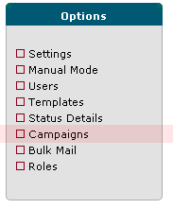

Campaign List

This screen shows list of all the campaigns available in the system. This is the main screen to manage campaigns. New campaigns can be added with add button. Existing campaigns can be updated by clicking on the link on campaign name. Campaigns can be deleted by selecting checkboxes and by clicking on the delete button. The send link next to each of the campaign takes to campaign sending screen where user groups can be seleted to which campaign needs to be sent.
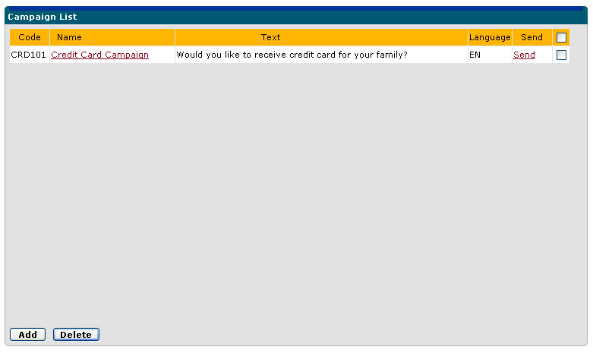

Campaign Creation

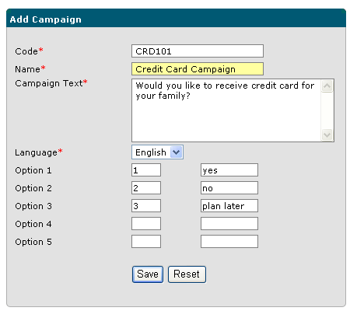
The code is sent as part of the message and customers are expected to send their responses along with campaign code. A Customer response for this campaign may look like:
CRD101 1
Customers can specify other details also as part of the message or any other options if they wish too. For example:
CRD101 Not Interested
All the responses will be captured and shown as part of the campaign Log report

Campaign Update

This screen is used to modify campaign. New options can be added, options can be modified and campaign text can also be modified. Campaign Code is not allowed to be changed.
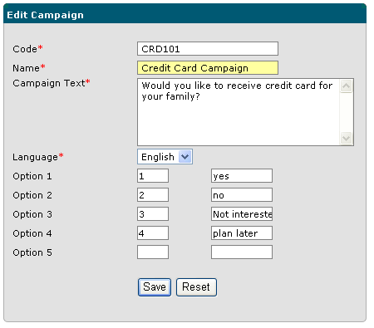

Campaign Message Sending

Messages will be created based on the options provided in the campaign creation section. To send a campaign message, Users need to click on the send link next to campaign in the campaign list. The users are presented with generated campaign message and list of groups available in the system. Users can select multiple groups and send campaign messages to these groups.

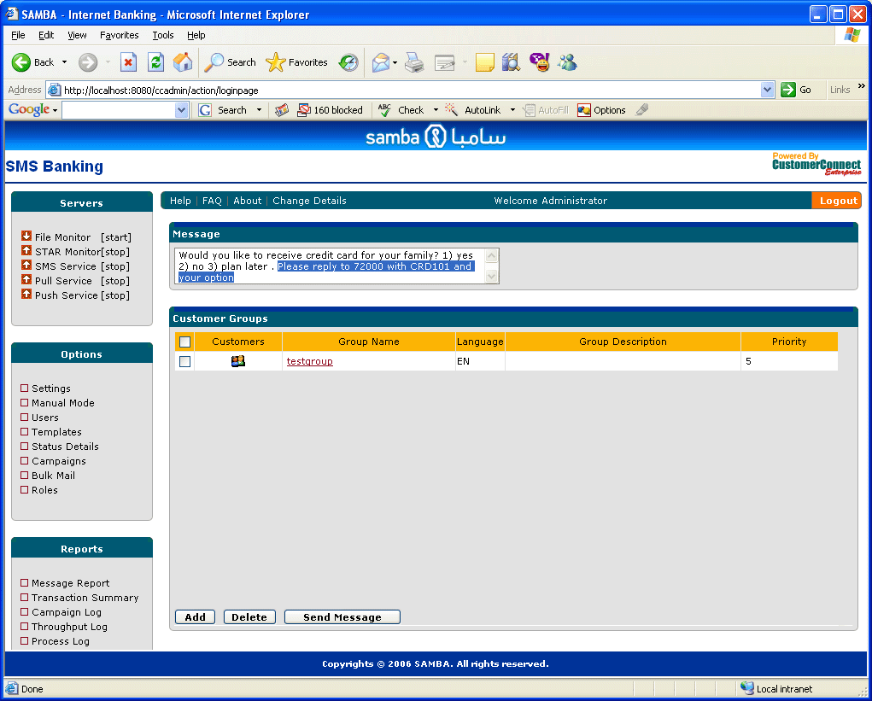

The selected text in the screen above is appended as a suffix to the campaign message. This information is defined in the template with “CampSuffix” code. Changing the message in the “CampSuffix” template will change the message accordingly. The “CampSuffix” template is defined for both English and Arabic messages. The template text contains ${code} parameter, which is replaced with the Campaign code while creating the Campaign message.

File Based Messaging

Bulk Messaging

Using Bulk Messaging Business Users can send messages to many customers in one go. CustomerConnect system picks up message file from a specified location. The source location is mentioned in the File Monitor settings (Source file location). Message is sent to all mobile numbers listed in the file. Following details shall be considered for the support of file based bulk messaging.

- All file names must have .txt as extension.
- English and Arabic messages shall be specified in different files.
- File names shall indicate the language of the message i.e. mobinfo_ar.txt for Arabic and mobinfo_en.txt for English.
- Multiple files can be placed in the source folder at one time. The language description in the name of the file is important. File name can be anything.
- First line of the file shall contain the message and rest of the lines shall have mobile numbers on separate lines.
- Arabic messages shall be saved as Unicode in the text file and English message should be saved in ASCII file.
- Based on parameter, mobile numbers shall be specified as local numbers without a leading zero or shall be specified as international number. The parameter is set from the administration screen as “Local” or “International”, as described in the settings panel in the server administration section of this document.

Following is the sample content of an Arabic file for bulk messaging:

عزيزنا سارع بتزويدنا بهويتكم المجددة لتجنب تجميد حسابكم لدينا
504190649
503448475
503439537
505446447
504280859
504169928
503227162
503150058
504127541
503201405
504471666

Personalized Messaging

A file based personalized bulk messaging requires a file with .per extension is put in the source folder. CustomerConnect picks this personalized message files and sends messages for all mobile numbers in the file. Following details need to be considered while sending personalized messages.

- All file names must have .per as extension.
- English and Arabic messages shall be specified in different files.
- File names shall indicate the language of the message i.e. mobinfo_ar.per for Arabic and mobinfo_en.per for English.
- Multiple files can be placed in the source folder at one time. The language description in the name of the file is important. File name can be anything.
- All the lines will have mobile number and personalized message separated by a “;” delimeter
- Arabic messages shall be saved as Unicode in the text file.
- Based on parameter, mobile numbers shall be specified as local numbers without a leading zero or shall be specified as international number. The parameter will be set from the administration screen as “Local” or “International”

966505454649;عزيزي العميل لقد تم اكتتابك في شركة ينساب بنجاح ورقم اكتتابك 18500003
966508888664;عزيزي العميل لقد تم اكتتابك في شركة ينساب بنجاح ورقم اكتتابك 19870440
966554422398;عزيزي العميل لقد تم اكتتابك في شركة ينساب بنجاح ورقم اكتتابك 19870457
966502884321;عزيزي العميل لقد تم اكتتابك في شركة ينساب بنجاح ورقم اكتتابك 19870464
966555273998;عزيزي العميل لقد تم اكتتابك في شركة ينساب بنجاح ورقم اكتتابك 19870471
966504295912;عزيزي العميل لقد تم اكتتابك في شركة ينساب بنجاح ورقم اكتتابك 19870488
966500892609;عزيزي العميل لقد تم اكتتابك في شركة ينساب بنجاح ورقم اكتتابك 19870495
966555262453;عزيزي العميل لقد تم اكتتابك في شركة ينساب بنجاح ورقم اكتتابك 19870501
966501119996;عزيزي العميل لقد تم اكتتابك في شركة ينساب بنجاح ورقم اكتتابك 19870518
966556688546;عزيزي العميل لقد تم اكتتابك في شركة ينساب بنجاح ورقم اكتتابك 15701137
966553531251;عزيزي العميل لقد تم اكتتابك في شركة ينساب بنجاح ورقم اكتتابك 19870525

Messaging constraints

- In order to avoid duplicate file sending, there is a restriction for files which have been sent can be sent again only after seven days. Therefore, users are expected to specify different file names for sending different bulk messages.

- The total number of mobile numbers should not exceed 100,000 in a single file. In case numbers of customers are more than this limit, Users are expected to split them into multiple files, with same message in both the file in the first line of the file.

Pull Messaging

Pull Messaging requires retrieval of data from back-end system for the mobile interactive banking requests from customers. CustomerConnect system provides pull messaging capability in which it sends the received messages from SMSC to Samba’s middleware for further processing. The URL for middleware service is provided using Pull Service URL setting in the settings screen. Following types of Pull messages are handled by CustomerConnect Pull Service.

Normal Pull Message

CustomerConnect will receive the message from the SMSC and checks if the received message is part of any campaign or not. If message is not part of any campaign, it is considered as a normal Pull message and forwarded to the Pull Service. Following information is passed to the Samba’s back-end service:

- Mobile Number
- Message Text (Short Code)
- Message Language
- Unique Id for every message

The Samba’s backend service returns a valid or invalid response based on short code. If the response is valid, received messages are logged properly otherwise error message is sent to the customer based on return code returned by the Servlet.

These error messages are required to be maintained in template; otherwise no message will be sent to customers in case the Samba’s pull service sends an invalid response. Following are the error messages currently defined for Pull service as part of the template. The ${keyword} parameter is replaced with sent short code by Customer.

 | 010 | EN | ERROR | Keyword ${keyword} service not available
 | 011 | AR | ERROR | ${keyword} خدمة الإسم الخاص غير متوفرة
 | 030 | EN | ERROR | Message code ${keyword} is invalid
 | 031 | AR | ERROR | خدمة الإسم الخاص ${keyword} غير متوفرة
 | 050 | EN | ERROR | ${keyword} You are not registered for Samba SMS service.
 | 051 | AR | ERROR | ${keyword} الهاتف غير مسجل في خدمة سامبا للجوال البنكي

Campaign Messages

All received message are checked whether they are part of a campaign or not. If messages are campaign messages, they are passed on to campaign processor, which logs all campaign message in a Campaign Log and can be seen using Campaign Logs.

Delivery Response

CustomerConnect can receive delivery response also as pull message. The delivery response is identified and is logged as delivered message in the Message Log

Bulk E-Mail

File Based Mailing

CustomerConnect provides file based Bulk mailing capability. A text file containing emails can be put in the source repository for SMS messages with extension “.elm”. All such file will be considered for bulk emailing. Following details need to be considered for file-based bulk mailing :

- All file names must have .elm as extension.
- English and Arabic messages shall be specified in different files.
- File names shall indicate the language of the message i.e. mailnews_ar.txt for Arabic and mailnews_en.txt for English.
- Multiple files can be placed in the source folder at one time. The language description in the name of the file is important. File name can be anything.
- First line of the file shall contain the body of the mail and rest of the lines shall have email ids of customers on separate lines.
- Arabic messages shall be saved as Unicode in the text file and English message should be saved in ASCII file.
- The messages are always sent as HTML. Therefore any HTML element can be included in the mail text.
- From address and subject for the mail can be specified in the first line of the mail file after the message and separating them with pipe character. In case from address is not specified in the mail, the default from address will be taken from the mail settings specified in the settings screen.

Following figure shows the details of a mail text file.

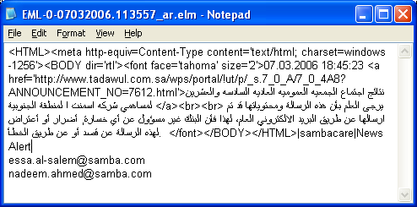

The from-address specified after message is “sambacare” and subject is “news”.

Web based mailing

System provides capability of sending email messages to specified e-mail addresses. The email addresses in an ASCII text file just like mobile numbers. Users can specify From-address, Subject, Message text and file from which email addresses needs to be picked up. After clicking on the save button, Email messages are loaded in the queue for processing.

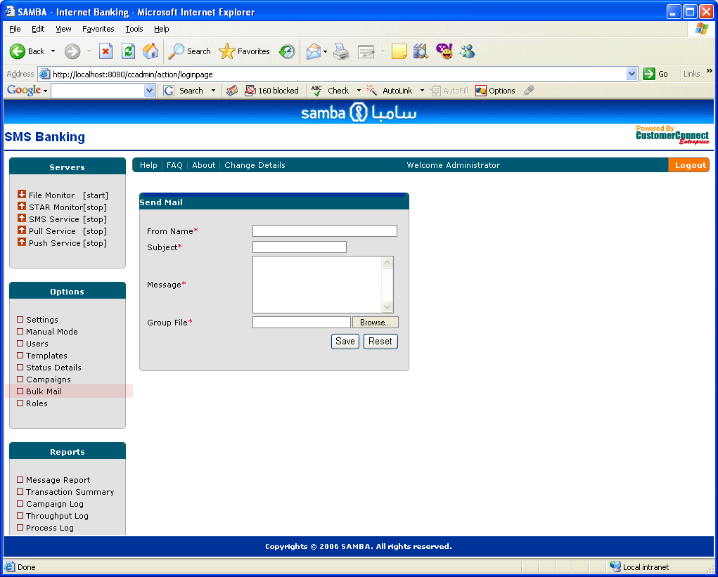

Following image displays the file format, required for bulk mailing.

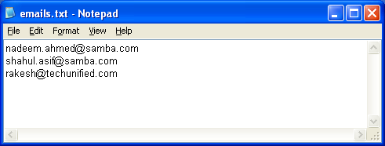

Status Monitor

CustomerConnect Enterprise provides a detailed status monitoring screen in order to check the health of the system. The status monitor is available for administrator users and can be accessed using Status Details link in the menu option. Status details are refreshed at a regular interval of 10 seconds, based on database access interval, the refresh time might be more than 10 seconds.

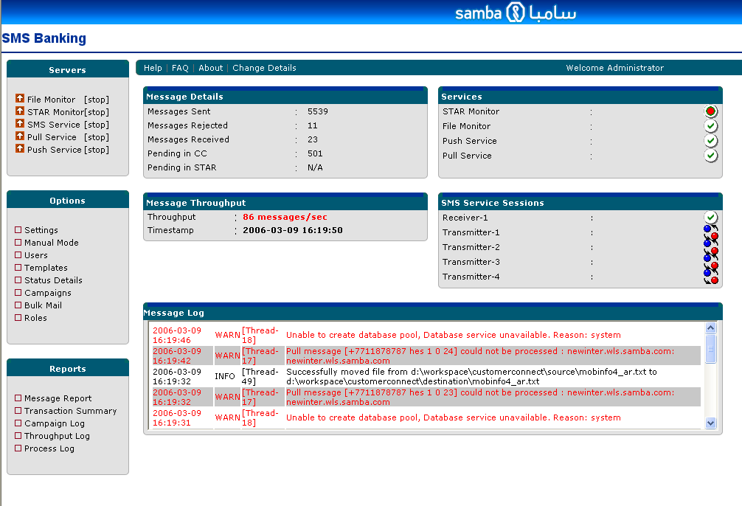
Here are the details of various sections in Status Monitor Screen:

Message Details Section

This section provides details of messages processed and which are under progress through this system. The details displayed in this section are:

- Messages Sent : Total number of messages sent from this system
- Messages Rejected: Total number of messages rejected from the system
- Messages Received: Total number of messages received from the Pull Service
- Pending in CC: Total number of messages remaining in CustomerConnect output Queue for processing
- Pending in STAR: Total number of messages pending in Samba’s database.

Message Throughput Section

This section provides throughput details:

- Throughput : Current through put in messages / second
- Timestamp : The time at which the status has been reported

Services Section

This section provides details of status of all the services available in the system, whether they are running, stopped or unavailable state. The following table describes the status of all these services, based on the icon displayed in the screen:

Service/Icon Status
File Monitor | Running | Stopped | N/A
STAR Monitor | Running | Stopped | Monitor is running but database connection is not available
Pull Service | Running | Stopped | N/A
Push Service | Running | Stopped | N/A

SMS Service Section

This section provides details of status of gateway sessions with STC. The list displays all transmitters and receiver sessions configured for CustomerConnect enterprise. If this list does not displays any thing. Either no service is configured or the SMS Service is stopped completely. If SMS Service is started, this section will display list of all transmitters and receives configured. Following list displays the status of these sessions.

The session is configured correctly and it is bound properly with SMSC and is ready to send message
The session is not connected to the gateway, check in error logs for further details

Session is processing messages

Message Log Section

This section provides details of all the information and error messages which are generated by the system while processing SMS messages. All informational messages are colored in black and all warning and error messages are generated in Red, which need attention. The message log displays only last few sets of messages. The complete list of error messages can very well obtained in the error logs described in the error logs section.

Log File specification

All the log files related to CustomerConnect Enterprise application are stored in the specified log location in system setting.

Application Specific Logs

There are five types of log information generated by system:

- Message Log – captures all the messages processed by application with time stamp and the source location. The file storage format is Unicode so as to capture Arabic message. These logs are maintained on a daily basis and are used as a source for report generation. Since these log files are Unicode files, it is advisable not to edit these files manually, as report generation procedure may fail to parse the saved files in the native windows environment.

- System log – All system generated warnings, information and errors are captured in this file. This is also rolled on a daily basis. Content from this file is shown in the status monitor as well for a given day.

- Debug log – This log file contains debug information for SMS messages, their internal system processing details like PDU formation, sending over the socket. This file is helpful while trouble shooting system errors if there are any. The file contents are rolled over and purged based on size. This file is generated only if the debug feature is enabled through the configuration settings parameter. This is the highest level of debugging, therefore has performance implications and should not be enabled in production environment.

- Event log – This log files captures various exceptions occurred during message processing. This log file also helps in debugging. This file is generated only if the debug feature is enabled through the configuration settings parameter.

Access Logs

All console output is captured in root directory of installation on the server in a file called “stdout.log” (Generally D:\Programe Files\CustomerConnect Enterprise). This file is rolled over based on size. A maximum of five such files will be available in the installation folder:
Stdout.log
Stdout.log.1
Stdout.log.2
Stdout.log.3
Stdout.log.4
Therefore, only last few days’ information will be available in this file. This file contains debug information related to application processing and provides additional details along with the system log file.

Mail Alerts
CustomerConnect provides mail based alerts for critical error while sending the message. Email ids to which mails are sent are configured through the mail settings parameters. Following scenarios have been configured for mail based alerts :
- If Connectivity to the SMS gateway is not available for all the transmitters for more than 10 minutes. Mail alert is sent to configured email Ids
- If any of the services are stopped from running, mail alert is sent.

User Guide, FAQ and Product information and Change Details

Further information about customer connect is displayed by selecting Help menu item. The help menu item provides three sub menu items. “Help” is for displaying this user guide “FAQ” is for some important questions for users and “About” is for displaying additional information about CustomerConnect. The “Change Details” menu item is for users to change their personal details like password and name display.

Change Details
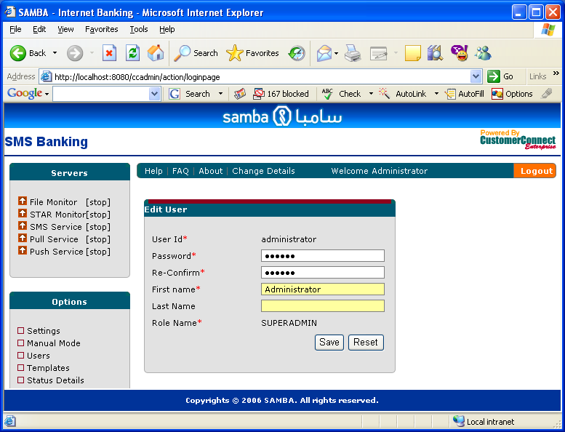

Help

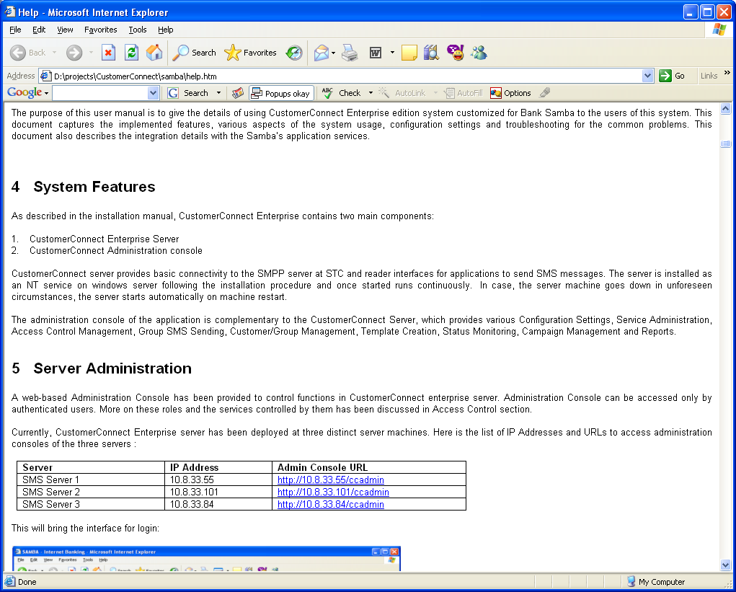

FAQ

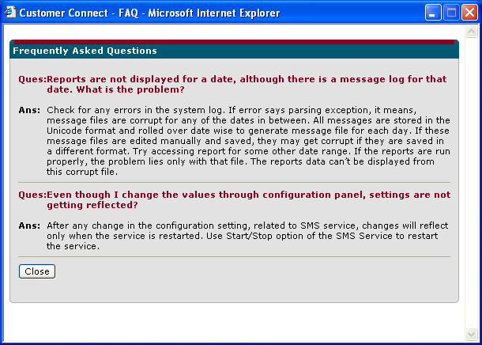

Product Information

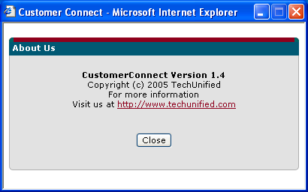

Frequently Asked Questions
This section can also be viewed separately by following the FAQ link.

Q. Reports are not displayed for a date, although there is a message log for that date. What is the problem?

Check for any errors in the system log. If error says parsing exception, it means, message files are corrupt for any of the dates in between. All messages are stored in the Unicode format and rolled over date wise to generate message file for each day. If these message files are edited manually and saved, they may get corrupt if they are saved in a different format. Try accessing report for some other date range. If the reports are run properly, the problem lies only with that file. The reports data can’t be displayed from this corrupt file.

Q. Even though I change the values through configuration panel, settings are not getting reflected?

After any change in the configuration setting, related to SMS service, changes will reflect only when the service is restarted. Use Start/Stop option of the SMS Service to restart the service.

If there is any mismatch between the language selected and language of the selected group appropriate warning message will be displayed and message will not be sent to the different language group.

Appendix A : List of Application Ids and their Description

1 | Tadawul - old
2 | Treasury
3 | Current Account
4 | Ecare Alerts
5 | 2 Way SMS
6 | 2 Way SMS Registration
7 | STL News
8 | IPO Allocation
9 | Credit Cards
10 | Loans & PF
11 | Financial Plans
12 | Time Deposit
13 | BM Alerts
14 | Utility Alerts
15 | Status Alerts
16 | Mena FN
17 | Mutual Funds
20 | Portfolio market value
21 | Top gainers in portfolio
22 | Top losers in portfolio
23 | Favorite stocks in portfolio
24 | Fully executed order device
25 | Top gainers in Market
26 | Top losers in market
27 | Favorite stocks in market
28 | Market Index
29 | Company Announcements
50 | Others
66 | ATM Transactions
97 | Bulk
98 | Personalized
99 | Group
100 | CCE

Appendix B : List of errors

Errors displayed on web console :

Error Message | Page | Description
Unable to create group, group already exists | Group Creation | Duplicate groups are not permitted for the same language. If user wants to create a new group with a group name which already exists, this message appears.
Unable to create group, group already exists | Group Update | Duplicate groups are not permitted for the same language. If user wants to create a new group with a group name which already exists, this message appears.
Unable t o create group: Error at line 1 file < groupName.txt> | Group Creation | These messages appears if the format of file name being imported for the group is not valid. The error message indicates the line number where the problem is.
Unable to update customer for numbers : <number1>, <number 2> | Customer Management | Duplicate mobile numbers are not allowed for customers. Therefore, while modifying the customers if mobile numbers are changed to existing mobile numbers. This error is displayed on the screen.
Unable to send Message  <groupName>: Different language group | Bulk Message Sending | While sending messages in manual mode. If language of message is different from language of either of groups of customers selected, this message is displayed and SMS is not sent to any of the customers
Unable to send Message  <groupName>: Message is already sent | Bulk Message Sending | In order to avoid duplicate message sending for a group, there is a restriction that if a message is sent to a group on a day, a new bulk message can only be sent next day to the same group. This message indicates that bulk message has already been sent to the group. SMS messages are not sent to such groups
UserId already exists | User Creation | Duplicate user Ids are not permitted
Passwords do not match | User Creation | Password and confirmation password while creating a user must match
Template already exists | Template creation | Duplicate template Ids are not permitted
Campaign already exists | Campaign creation | Duplicate campaign codes are not permitted in the system
Role already exists | Role creation | Duplicate role names are not permitted
From Date is greater than To Date | Report Display | If the selected From Date is less than the To Date while generating report, this message is displayed.

Errors displayed in the log files

Unable to load configuration from database <error> | Configuration details are mandatory for CustomerConnect to run. This error can come because of misconfiguration. Application will not work in case of this error.
Service is already running | If an already running service is started, this error will be displayed
Message could not be sent to <mobile number> | IF because of connectivity failure, message is not sent to mobile numbers this message is displayed. The message will be recycled, this is just for information purpose
Location <location> in an invalid file location | If source file location specified in the setting parameter is invalid, this error message will be displayed
Error in reading file : {filepath} | If the file format of bulk message is not correct. This error will be displayed
Unable to list files in the directory: {directory name} | If permission is not given in either of the source, destination or error directory, this error will be displayed
File monitor terminated unexpectedly {reason} | If there is a problem with file monitor, this error will be displayed. Please restart the file monitor in case this error comes
Stopping file monitor | If someone tries to stops the file monitor
File Monitor could not be started : {reason} | Appears when file monitor settings are improper, reason is displayed along with the message
FileMonitor will not run, as we have an invalid interval | Invalid interval for the running of file monitor
File {file name} processed successfully for sending messages | Information message for file processing
File {filename} could not be processed (reason) | Specified file is not processed because of error. The reason is also displayed along with the file name
Successfully moved file from {source} to {destination} | Informational message before file processing
Unable to rename file from {source} to {destination} | Internal error message, if the file being processed is in use by some other application, this message will be displayed
File name ({file name}) is not valid | If the naming convention of the bulk message file is not proper, this message will be displayed
Language extension of file is not valid | If file language extension is other than en and ar, this error message is displayed
Destination directory is invalid | Invalid destination directory specified in the settings parameter
Error destination directory is invalid | Invalid error directory specified in the settings parameter
Error while parsing the file {filename} : {error message} | If the file format is not proper this error message will be displayed
Unable to process the file {reason} | Other errors while processing the file, with reason
File {filename} has already been sent for processing | To avoid duplicate file sending, a file with the same same name can only be sent after seven days. This message says the file already exists in the destination folder
Not a right time to send the SMS | If the time restriction settings is applied for the bulk messages. This error message is displayed for bulk messages which are sent during restricted time
{monitor} stopped successfully. | Specific monitor has been stopped successfully.
{monitor} started successfully | When specific monitor is started successfully. Wait for this message while starting the monitor
Unable to create database pool, Database service unavailable. Reason: {reason} | If CustomerConnect is unable to connect to the STAR database. This error message is displayed with error
No database connection available | Informational message for database monitor. If it is unable to send message because of database connectivity
Error in processing database messages: {reason} | If messages read from database are not proper, they are not sent for processing. The reason is displayed
Read {number} records from STAR | Displays how many records have been selected from STAR. Informational message
Unable to execute query: {query} : {reason} | If query executed for STAR database fails. This error is displayed with reason
Error processing pull message : {reason} | If there is a problem in processing pull message. Displayed with error description
Error in SMTP configuration, error mailing services will not be active : {reason} | SMTP server is not proper or it is unavailable. Please check the host name and connectivity for SMTP server
Successfully bound to the SMPP server [{ipaddress}-{port}] | SMPP connection is proper and bind operation has been successful
Bind operation failed for {ipaddress} : {port} | Bind operation could not succeed because of connection failure. Please check the connectivity
{monitor} can't process data, no SMPP binding available | If none of the transmitters are processing messages file monitor and database monitor stops picking up messages and loading them into queue. This error message indicates the same.
Unable to send message for {mobile}, {reason} | If message is not sent to a particular mobile. This message is logged. Only informational log message. SMS message will be recycled
Error while sending messages {reason} | General error, while sending the message. Need to validate reason for details
{totalCount} messages processed,Source: {file}, Sent:{sent messages}, Rejected:{rejected Messages}. | At the end of processing bulk file. This informational message is logged
SMTP server is not configured | If SMTP server is not working properly, this message is displayed while sending mail alerts
From date is greater than To date
Receiver session unavailable | If binding is not available for Receiver . Pull message will not be processed. Check for receiver connectivity
No active consumers are available for message, {monitor} not processing. | If none of the transmitters are processing messages file monitor and database monitor stops picking up messages and loading them into queue. This error message indicates the same.
Mail service is not available for file {fileName} | If SMTP service is not available, Bulk mails can not be sent
Pull message [{message}] could not be processed : {reason} | If pull messages are not processed this message is displayed with reason

